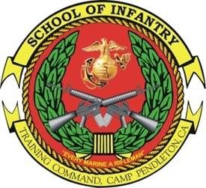INTERMEDIATE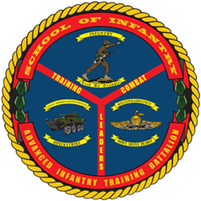
COMBAT HUNTER COURSE
Course ID: M10HE6M
- Purpose: The purpose of the Combat Hunter Trainer Course is to produce a more ethically minded, tactically cunning, and situational aware Marine capable of proactively identifying threats in any environment.

- Scope: The Intermediate Combat Hunter Course is designed to foster and develop a hunter mindset through the integration of enhanced observation, profiling, and tracking skills. A Marine receives training in day, night, and thermal optics, enhanced observation, profiling an anomaly, and tracking techniques.

- Task List:
  - 1000 Level:
    - Conduct observation
    - Identify anomalies
    - Identify spoor
    - Explain the decision cycle (OODA) process
    - Analyze spoor
    - Perform individual actions as a tracker
    - Profile an anomaly

- Length: 1 Weeks (5 Training Days)

- Prerequisites:
    - Active duty or reserve Marine

    - Must not have any personal, legal, or medical issues that would interfere with his ability to complete the course.

- Registration: Due to student allocation issues with MCTIMS for this particular CID, units must contact and forward a roster of students to the Combat Hunter Chief Instructor. The Combat Hunter Chief Instructor can be reached at (760) 725-6811.

- Check-In Procedures: Students will check-in to Building 64443 (Camp Talega), Camp Pendleton, CA between 0630 and 0700 on the course convene date. Students will have a command screening checklist upon check in. Students traveling to Camp Pendleton from other duty stations need to coordinate lodging arrangements with the Combat Hunter Chief Instructor at (760) 725-6811 prior to the course convening in order to prevent any travel/lodging issues.

